DECLARATION

This is to certify that Project Report entitled “IR PULSE DETECTOR AND HEART RATE MONITOR ” which is submitted by me in partial fulfillment of the requirement for the award of Degree of Bachelor of Instrumentation , only my original work and due acknowledgement has been made in the text to all other material used.

DHARMESH BHARDWAJ (1505008)
RITESH DHIMAN (1505084)
LAKSHAY BHATIA (1505059)
ROHIT KUMAR (1505073)
PERDEEP KUMAR (1505086)

INTORDUCTION

In this project we demonstrate the idea of heart beat monitoring and patient heart analyser system. In this project we check the patient parameter such as heart beat. In this project we measure the heart beat that sense and measure the heart beat and display in lcd, and it plot the wave on serial plotter.
In this project we take different mode
Heart beat measure mode: in this mode we measure the heartbeat and display in lcd and this condition plot the graph wave on serial plotter .

COMPONENTS
- ARDUINO UNO,
- Transformer(9-0-9),
- Diode(in4007),
- Resistor(1k,470ohm,10k,270ohm),
- Capacitor(10uf,1000uf,27pf),
- Regulator(7805),
- Npnbc-547,and bc-557pnp,
- Led,
- Pcb,
- Relay,
- Battery,
- Switch,
- Battery.

SOFTWARE USED
- ARDUINO IDE,
- Topwin for ic programming,
- Proteus software for ckt design,
- Coding lan: assembly language.

MODE OF PROJECT
- We make the power supply,
- Moisture sensor/temperature sensor module interface,
- Heart beat sensor interface,
- WIFI MODULE INTERFACE,
- Android application interface.
PROBLEM CONTENT
- Components availability,
- How to decide value of components,
- Circuit designing,
- How to give the effort of soldering properly,
- Programming of sensor,
- signal sending and,
- sensor interfacing.

LEARNING OBJECTIVE
- circuit designing on proteus software,
- Pcb layout on ARES software,
- Programming language embedded c and assembly,
- How to use keil software,
- Generate the hel file,
- How toburn the ic,
- How to do the soldering.

TECHNICAL PROSPECTIVE IDEA
- Printed circuit board size: 9x5.
- Mdf board size 18x12.
- Height 5cm.

PROJECT PRAPOSAL METHODOLOGY
We make a project in different mode:
- Ist mode:
In this mode we design over all frame script such as
- Idea of project,
- Components list,
- Circuit diagram.
- 2nd mode:
In this mode we calculate the value of
- Components.
- Decide the component rating.
- Name of components that may be use in project.
- Purchase the components.
- 3rd Mode:
- In this mode we design a circuit on pcb.
- Assemble the components.
- Test the soldering dry or not.
- 4th mode:
in this mode we software for coding.
- We use keil software.
- We design a code in assembly or embedded c.
- We create the hex file.
- 5th mode:
- in this mode we design a circuit diagram on proteus for simulation
- try to simulation on proteus.
- 6th mode:
- In this mode we use the top-win software.
- We programmed the ic.
- 7th mode :
- in this mode we test the features of project.
TESTING TOOL
- Multi-meter,
- Switch,
- Battery,
- Cro,
- Scope,
- Led indication.

Circuit diagram receiver

POWER SUPPLY

Heart beat
LCD

ARDUINO

Adc

Relay
buzzer

Driver ckt

CIRCUIT DIAGRAM

MATERIAL REQUIRED
The apparatus needs for making a P.C.B. is :-
- Copper Clad Sheet
- Nail Polish or Paint
- Ferric Chloride Powder. (Fecl)
- Plastic Tray
- Tap Water etc.

PROCEDURE
The first and foremost in the process is to clean all dirt from copper sheet with say spirit or trichloro ethylene to remove traces grease or oil etc. and then wash the board under running tap water. Dry the surface with forced warm air or just leave the board to dry naturally for some time.
Making of the P.C.B. drawing involves some preliminary consideration such as thickness of lines/ holes according to the components. Now draw the sketch of P.C.B. design (tracks, rows, square) as per circuit diagram with the help of nail polish or enamel paint or any other acid resistant liquid. Dry the point surface in open air, when it is completely dried, the marked holes in P.C.B. may be drilled using 1Mm drill bits. In case there is any shorting of lines due to spilling of paint, these may be removed by scraping with a blade or a knife, after the paint has dried.
After drying, 22-30 grams of ferric chloride in 75 ml of water may be heated to about 60 degree and poured over the P.C.B. , placed with its copper side upwards in a plastic tray of about 15*20 cm. Stirring the solution helps speedy etching. The dissolution of unwanted copper would take about 45 minutes. If etching takes longer, the solution may be heated again and the process repeated. The paint on the pattern can be removed P.C.B. may then be washed and dried. Put a coat of varnish to retain the shine. Your P.C.B. is ready.
REACTION
Fecl3 + Cu ----- CuCl3 + Fe
Fecl3 + 3H2O --------- Fe (OH)3 + 3HCL

PRECAUTION
1. Add Ferric Chloride (Fecl3) carefully, without any splashing. Fecl3 is irritating to the skin and will stain the clothes.
2. Place the board in solution with copper side up.
3. Try not to breathe the vapours. Stir the solution by giving see-saw motion to the dish and solution in it.
4. Occasionally warm if the solution over a heater-not to boiling. After some time the unshaded parts change their colour continue to etch. Gradually the base material will become visible. Etch for two minutes more to get a neat pattern.
5. Don't throw away the remaining Fecl3 solution. It can be used again for next Printed Circuit Board P.C.B.

USES
Printed Circuit Board are used for housing components to make a circuit for compactness, simplicity of servicing and case of interconnection. Thus we can define the P.C.B. as : Prinked Circuit Boards is actually a sheet of bakelite (an insulating material) on the one side of which copper patterns are made with holes and from another side, leads of electronic components are inserted in the proper holes and soldered to the copper points on the back. Thus leads of electronic components terminals are joined to make electronic circuit.

In the boards copper cladding is done by pasting thin copper foil on the boards during curing. The copper on the board is about 2 mm thick and weights an ounce per square foot.

The process of making a Printed Circuit for any application has the following steps (opted professionally):
- Preparing the layout of the track.
- Transferring this layout photographically M the copper.
- Removing the copper in places which are not needed, by the process of etching (chemical process)
- Drilling holes for components mounting.

PRINTED CIRCUIT BOARD

Printed circuit boards are used for housing components to make a circuit, for comactness, simplicity of servicing and ease of interconnection. Single sided, double sided and double sided with plated-through-hold (PYH) types of p.c boards are common today.
Boards are of two types of material (1) phenolic paper based material (2) Glass epoxy material. Both materials are available as laminate sheets with copper cladding.
Printed circuit boards have a copper cladding on one or both sides. In both boards, pasting thin copper foil on the board during curing does this. Boards are prepared in sizes of 1 to 5 metre wide and upto 2 metres long. The thickness of the boards is 1.42 to 1.8mm. The copper on the boards is about 0.2 thick and weighs and ounce per square foot.

HARDWARE/COMPONENTS DETAIL
- POWER SUPPLY
All digital circuits require regulated power supply. In this article we are going to learn how to get a regulated positive supply from the mains supply.

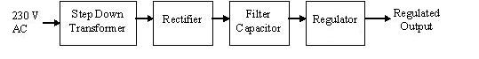
Figure 1 shows the basic block diagram of a fixed regulated power supply. Let us go through each block.

- TRANSFORMER
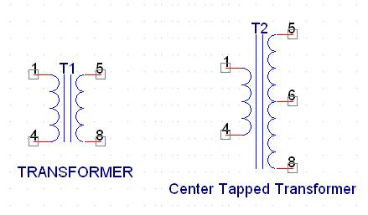
A transformer consists of two coils also called as “WINDINGS” namely PRIMARY & SECONDARY.
They are linked together through inductively coupled electrical conductors also called as CORE. A changing current in the primary causes a change in the Magnetic Field in the core & this in turn induces an alternating voltage in the secondary coil. If load is applied to the secondary then an alternating current will flow through the load. If we consider an ideal condition then all the energy from the primary circuit will be transferred to the secondary circuit through the magnetic field.
So 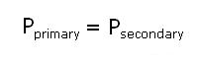
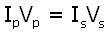
The secondary voltage of the transformer depends on the number of turns in the Primary as well as in the secondary.
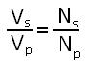

- Rectifier
A rectifier is a device that converts an AC signal into DC signal. For rectification purpose we use a diode, a diode is a device that allows current to pass only in one direction i.e. when the anode of the diode is positive with respect to the cathode also called as forward biased condition & blocks current in the reversed biased condition.
Rectifier can be classified as follows:
1) Half Wave rectifier.
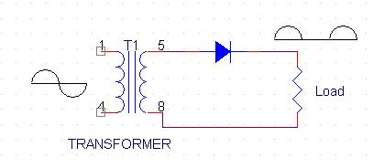
This is the simplest type of rectifier as you can see in the diagram a half wave rectifier consists of only one diode. When an AC signal is applied to it during the positive half cycle the diode is forward biased & current flows through it. But during the negative half cycle diode is reverse biased & no current flows through it. Since only one half of the input reaches the output, it is very inefficient to be used in power supplies.
2) Full wave rectifier.
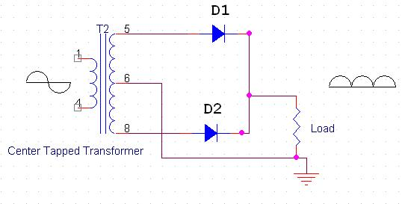
Half wave rectifier is quite simple but it is very inefficient, for greater efficiency we would like to use both the half cycles of the AC signal. This can be achieved by using a center tapped transformer i.e. we would have to double the size of secondary winding & provide connection to the center. So during the positive half cycle diode D1 conducts & D2 is in reverse biased condition. During the negative half cycle diode D2 conducts & D1 is reverse biased. Thus we get both the half cycles across the load.
One of the disadvantages of Full Wave Rectifier design is the necessity of using a center tapped transformer, thus increasing the size & cost of the circuit. This can be avoided by using the Full Wave Bridge Rectifier.

3) Bridge Rectifier.
As the name suggests it converts the full wave i.e. both the positive & the negative half cycle into DC thus it is much more efficient than Half Wave Rectifier & that too without using a center tapped transformer thus much more cost effective than Full Wave Rectifier.
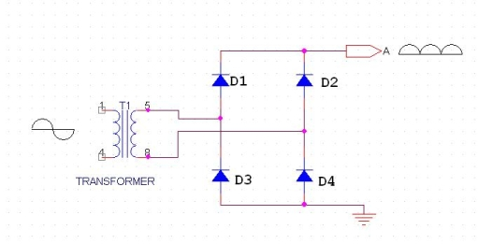
Full Bridge Wave Rectifier consists of four diodes namely D1, D2, D3 and D4. During the positive half cycle diodes D1 & D4 conduct whereas in the negative half cycle diodes D2 & D3 conduct thus the diodes keep switching the transformer connections so we get positive half cycles in the output.
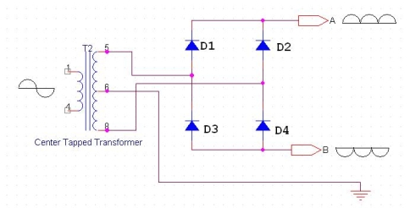

If we use a center tapped transformer for a bridge rectifier we can get both positive & negative half cycles which can thus be used for generating fixed positive & fixed negative voltages.

- FILTER CAPACITOR
Even though half wave & full wave rectifier give DC output, none of them provides a constant output voltage.For this we require to smoothen the waveform received from the rectifier. This can be done by using a capacitor at the output of the rectifier this capacitor is also called as “FILTER CAPACITOR” or “SMOOTHING CAPACITOR” or “RESERVOIR CAPACITOR”. Even after using this capacitor a small amount of ripple will remain.
We place the Filter Capacitor at the output of the rectifier the capacitor will charge to the peak voltage during each half cycle then will discharge its stored energy slowly through the load while the rectified voltage drops to zero, thus trying to keep the voltage as constant as possible.
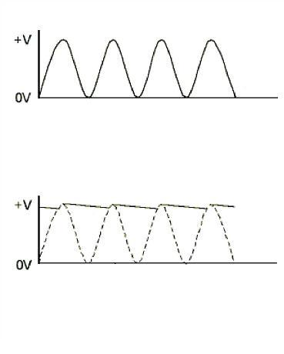

If we go on increasing the value of the filter capacitor then the Ripple will decrease. But then the costing will increase. The value of the Filter capacitor depends on the current consumed by the circuit, the frequency of the waveform & the accepted ripple.

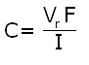

Where,
Vr= accepted ripple voltage.( should not be more than 10% of the voltage)
I= current consumed by the circuit in Amperes.
F= frequency of the waveform. A half wave rectifier has only one peak in one cycle so F=25hz
whereas a full wave rectifier has Two peaks in one cycle so F=100hz.

- VOLTAGE REGULATOR
A Voltage regulator is a device which converts varying input voltage into a constant regulated output voltage. voltage regulator can be of two types
- Linear Voltage Regulator:
Also called as Resistive Voltage regulator because they dissipate the excessive voltage resistively as heat.
- Switching Regulators:
They regulate the output voltage by switching the Current ON/OFF very rapidly. Since their output is either ON or OFF it dissipates very low power thus achieving higher efficiency as compared to linear voltage regulators. But they are more complex & generate high noise due to their switching action. For low level of output power switching regulators tend to be costly but for higher output wattage they are much cheaper than linear regulators.
The most commonly available Linear Positive Voltage Regulators are the 78XX series where the XX indicates the output voltage. And 79XX series is for Negative Voltage Regulators.
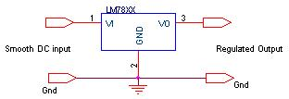
After filtering the rectifier output the signal is given to a voltage regulator. The maximum input voltage that can be applied at the input is 35V.Normally there is a 2-3 Volts drop across the regulator so the input voltage should be at least 2-3 Volts higher than the output voltage. If the input voltage gets below the Vmin of the regulator due to the ripple voltage or due to any other reason the voltage regulator will not be able to produce the correct regulated voltage

- DIODE
The simplest semiconductor device is made up of a sandwich of P-type semiconducting material, with contacts provided to connect the p-and n-type layers to an external circuit. This is a junction Diode. If the positive terminal of the battery is connected to the p-type material (cathode) and the negative terminal to the N-type material (Anode), a large current will flow. This is called forward current or forward biased.
If the connections are reversed, a very little current will flow. This is because under this condition, the p-type material will accept the electrons from the negative terminal of the battery and the N-type material will give up its free electrons to the battery, resulting in the state of electrical equilibrium since the N-type material has no more electrons. Thus there will be a small current to flow and the diode is called Reverse biased.
Thus the Diode allows direct current to pass only in one direction while blocking it in the other direction. Power diodes are used in concerting AC into DC. In this, current will flow freely during the first half cycle (forward biased) and practically not at all during the other half cycle (reverse biased). This makes the diode an effective rectifier, which convert ac into pulsating dc. Signal diodes are used in radio circuits for detection. Zener diodes are used in the circuit to control the voltage.

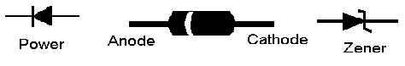

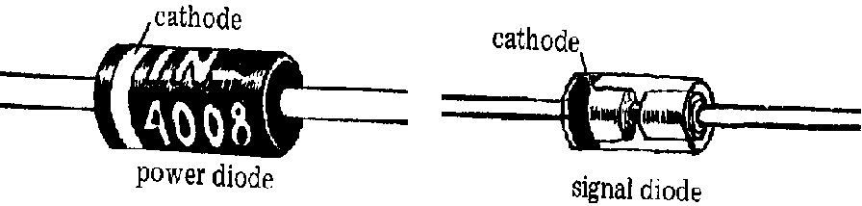

Some common diodes are:-
- Zener diode.
- Photo diode.
- Light Emitting diode.

1. ZENER DIODE:-
A zener diode is specially designed junction diode, which can operate continuously without being damaged in the region of reverse break down voltage. One of the most important applications of zener diode is the design of constant voltage power supply. The zener diode is joined in reverse bias to d.c. through a resistance R of suitable value.

2. PHOTO DIODE:-
A photo diode is a junction diode made from photo- sensitive semiconductor or material. In such a diode, there is a provision to allow the light of suitable frequency to fall on the p-n junction. It is reverse biased, but the voltage applied is less than the break down voltage. As the intensity of incident light is increased, current goes on increasing till it becomes maximum. The maximum current is called saturation current.

3. LIGHT EMITTING DIODE (LED):-
When a junction diode is forward biased, energy is released at the junction diode is forward biased, energy is released at the junction due to recombination of electrons and holes. In case of silicon and germanium diodes, the energy released is in infrared region. In the junction diode made of gallium arsenate or indium phosphide, the energy is released in visible region. Such a junction diode is called a light emitting diode or LED.

HOW LIGHT EMITTING DIODES WORK

Light emitting diodes, commonly called LEDs do dozens of different jobs and are found in all kinds of devices. Among other things, they form the numbers on digital clocks, transmit information from remote controls, light up watches and tell you when your appliances are turned on. Collected together, they can form images on a jumbo television screen or illuminate a traffic light.
Basically, LEDs are just tiny light bulbs that fit easily into an electrical circuit. But unlike ordinary incandescent bulbs, they don't have a filament that will burn out, and they don't get especially hot. They are illuminated solely by the movement of electrons in a semiconductor material, and they last just as long as a standard transistor.

DIODE

A diode is the simplest sort of semiconductor device. A semiconductor is a material with a varying ability to conduct electrical current. Most semiconductors are made of a poor conductor that has had impurities (atoms of another material) added to it. The process of adding impurities is called doping.
In the case of LEDs, the conductor material is typically aluminum-gallium-arsenide (AlGaAs). In pure aluminum-gallium-arsenide, all of the atoms bond perfectly to their neighbors, leaving no free electrons (negatively-charged particles) to conduct electric current. In doped material, additional atoms change the balance, either adding free electrons or creating holes where electrons can go. Either of these additions makes the material more conductive.
A semiconductor with extra electrons is called N-type material, since it has extra negatively charged particles. In N-type material, free electrons move from a negatively charged area to a positively charged area.
A semiconductor with extra holes is called P-type material, since it effectively has extra positively charged particles. Electrons can jump from hole to hole, moving from a negatively charged area to a positively charged area. As a result, the holes themselves appear to move from a positively charged area to a negatively charged area.
A diode comprises a section of N-type material bonded to a section of P-type material, with electrodes on each end. This arrangement conducts electricity in only one direction. When no voltage is applied to the diode, electrons from the N-type material fill holes from the P-type material along the junction between the layers, forming a depletion zone. In a depletion zone, the semiconductor material is returned to its original insulating state - all of the holes are filled, so there are no free electrons or empty spaces for electrons, and charge can't flow.

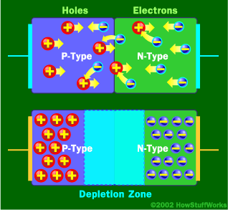
At the junction, free electrons from the N-type material fill holes from the P-type material. This creates an insulating layer in the middle of the diode called the depletion zone.

To get rid of the depletion zone, electrons should move from the N-type area to the P-type area and holes should move in the reverse direction. This is done by connecting the N-type side of the diode to the negative end of a circuit and the P-type side to the positive end. The free electrons in the N-type material are repelled by the negative electrode and drawn to the positive electrode. The holes in the P-type material move the other way. When the voltage difference between the electrodes is high enough, the electrons in the depletion zone are boosted out of their holes and begin moving freely again. The depletion zone disappears, and charge moves across the diode.
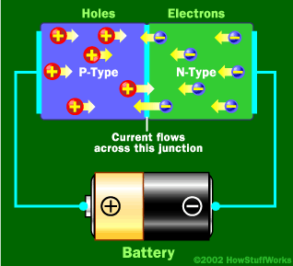
When the negative end of the circuit is hooked up to the N-type layer and the positive end is hooked up to P-type layer, electrons and holes start moving and the depletion zone disappears.

If current is run the other way, with the P-type side connected to the negative end of the circuit and the N-type side connected to the positive end, current will not flow. The negative electrons in the N-type material are attracted to the positive electrode. The positive holes in the P-type material are attracted to the negative electrode. No current flows across the junction because the holes and the electrons are each moving in the wrong direction. The depletion zone increases.

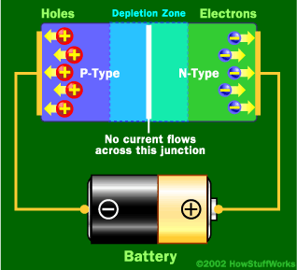
When the positive end of the circuit is hooked up to the N-type layer and the negative end is hooked up to the P-type layer, free electrons collect on one end of the diode and holes collect on the other. The depletion zone gets bigger.

The interaction between electrons and holes in this setup has an interesting side effect - it generates light.

HOW CAN A DIODE PRODUCE LIGHT?
Light is a form of energy that can be released by an atom. It is made up of many small particle-like packets that have energy and momentum but no mass. These particles, called photons, are the most basic units of light.
Photons are released as a result of moving electrons. In an atom, electrons move in orbitals around the nucleus. Electrons in different orbitals have different amounts of energy. Electrons with greater energy move in orbitals farther away from the nucleus.

For an electron to jump from a lower orbital to a higher orbital, something has to boost its energy level. Conversely, an electron releases energy when it drops from a higher orbital to a lower one. This energy is released in the form of a photon. A greater energy drop releases a higher-energy photon, which is characterized by a higher frequency.
As free electrons moving across a diode can fall into empty holes from the P-type layer. This involves a drop from the conduction band to a lower orbital, so the electrons release energy in the form of photons. This happens in any diode, but the photons are seen when the diode is composed of certain material. The atoms in a standard silicon diode, for example, are arranged in such a way that the electron drops a relatively short distance. As a result, the photon's frequency is so low that it is invisible to the human eye - it is in the infrared portion of the light spectrum. This isn't necessarily a bad thing, of course: Infrared LEDs are ideal for remote controls, among other things.
Visible light-emitting diodes (VLEDs), such as the ones that light up numbers in a digital clock, are made of materials characterized by a wider gap between the conduction band and the lower orbitals. The size of the gap determines the frequency of the photon -- in other words, it determines the color of the light.
While all diodes release light, most don't do it very effectively. In an ordinary diode, the semiconductor material itself ends up absorbing a lot of the light energy.
LEDs are specially constructed to release a large number of photons outward. Additionally, they are housed in a plastic bulb that concentrates the light in a particular direction. Most of the light from the diode bounces off the sides of the bulb, traveling on through the rounded end.
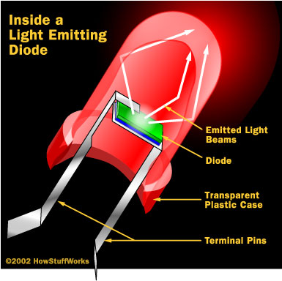
LEDs have several advantages over conventional incandescent lamps. For one thing, they don't have a filament that will burn out, so they last much longer. Additionally, their small plastic bulb makes them a lot more durable. They also fit more easily into modern electronic circuits.
But the main advantage is efficiency. In conventional incandescent bulbs, the light-production process involves generating a lot of heat (the filament must be warmed). is completely wasted energy, unless the lamp is used as a heater, because a huge portion of the available electricity isn't going toward producing visible light. LEDs generate very little heat, relatively. A much higher percentage of the electrical power is going directly to generating light, which cuts down on the electricity demands considerably.
Up until recently, LEDs were too expensive to use for most lighting applications because they're built around advanced semiconductor material. The price of semiconductor devices has plummeted over the past decade, however, making LEDs a more cost-effective lighting option for a wide range of situations. While they may be more expensive than incande front, their lower cost in the long run can make them a better buy. In the future, they will play an even bigger role in the world of technology.

CAPACITORS

It is an electronic component whose function is to accumulate charges and then release it.
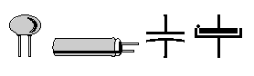

To understand the concept of capacitance, consider a pair of metal plates which all are placed near to each other without touching. If a battery is connected to these plates the positive pole to one and the negative pole to the other, electrons from the battery will be attracted from the plate connected to the positive terminal of the battery.
If the battery is then disconnected, one plate will be left with an excess of electrons, the other with a shortage, and a potential or voltage difference will exists between them. These plates will be acting as capacitors. Capacitors are of two types: - (1) fixed type like ceramic, polyester, electrolytic capacitors-these names refer to the
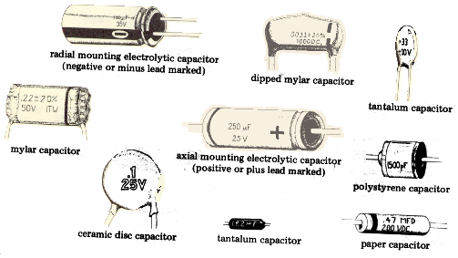

material they are made of aluminium foil. (2) Variable type like gang condenser in radio or trimmer. In fixed type capacitors, it has two leads and its value is written over its body and variable type has three leads. Unit of measurement of a capacitor is farad denoted by the symbol F. It is a very big unit of capacitance. Small unit capacitor are pico-farad denoted by pf (Ipf=1/1000,000,000,000 f) Above all, in case of electrolytic capacitors, it's two terminal are marked as (-) and (+) so check it while using capacitors in the circuit in right direction. Mistake can destroy the capacitor or entire circuit in operational.

RESISTANCE

Resistance is the opposition of a material to the current. It is measured in Ohms (Ω). All conductors represent a certain amount of resistance, since no conductor is 100% efficient. To control the electron flow (current) in a predictable manner, we use resistors. Electronic circuits use calibrated lumped resistance to control the flow of current. Broadly speaking, resistor can be divided into two groups viz. fixed & adjustable (variable) resistors. In fixed resistors, the value is fixed & cannot be varied. In variable resistors, the resistance value can be varied by an adjuster knob. It can be divided into (a) Carbon composition (b) Wire wound (c) Special type. The most common type of resistors used in our projects is carbon type. The resistance value is normally indicated by colour bands. Each resistance has four colours, one of the band on either side will be gold or silver, this is called fourth band and indicates the tolerance, others three band will give the value of resistance (see table). For example if a resistor has the following marking on it say red, violet, gold. Comparing these coloured rings with the colour code, its value is 27000 ohms or 27 kilo ohms and its tolerance is ±5%. Resistor comes in various sizes (Power rating). The bigger, the size, the more power rating of 1/4 watts. The four colour rings on its body tells us the value of resistor value as given below.

COLOURS CODE

Black 0
Brown 1
Red 2
Orange 3
Yellow 4
Green 5
Blue 6
Violet 7
Grey 8
White 9

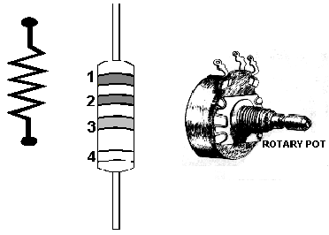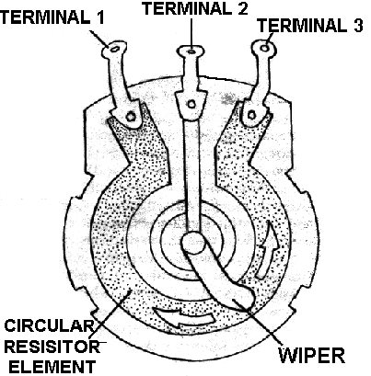
The first rings give the first digit. The second ring gives the second digit. The third ring indicates the number of zeroes to be placed after the digits. The fourth ring gives tolerance (gold ±5%, silver ± 10%, No colour ± 20%).
In variable resistors, we have the dial type of resistance boxes. There is a knob with a metal pointer. This presses over brass pieces placed along a circle with some space b/w each of them.
Resistance coils of different values are connected b/w the gaps. When the knob is rotated, the pointer also moves over the brass pieces. If a gap is skipped over, its resistance is included in the circuit. If two gaps are skipped over, the resistances of both together are included in the circuit and so on.
A dial type of resistance box contains many dials depending upon the range, which it has to cover. If a resistance box has to read upto 10,000Ω, it will have three dials each having ten gaps i.e. ten resistance coils each of resistance 10 Ω. The third dial will have ten resistances each of 100 Ω.
The dial type of resistance boxes is better because the contact resistance in this case is small & constant.
THE ADAPTING 3-TERMINAL VOLTAGE REGULATORS FOR CONSTANT HIGH VOLTAGE POWER SUPPLIES
One can get a constant high-voltage power supply using inexpensive 3-terminal voltage regulators through some simple techniques described below. Depending upon the current requirement, a reasonable load regulation can be achieved. Line regulation in all cases is equal to that of the voltage regulator used.
Though high voltage can be obtained with suitable voltage boost circuitry using ICs like LM 723, some advantages of the circuits presented below are: simplicity, low cost, and practically reasonable regulation characteristics. For currents of the order of 1A or less, only one zener and some resistors and capacitors are needed. For higher currents, one pass transistor such as ECP055 is needed.

Before developing the final circuits, let us first understand the 3-terminal type constant voltage regulators. Let us see the schematic in Fig. where 78XX is a 3-terminal voltage regulator.
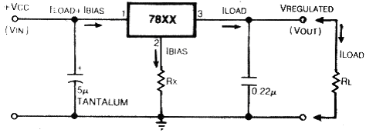Schematic for obtaining low-voltage regulated output using 3-terminal voltage regulators.

Rectified and filtered unregulated voltage is applied at V_{IN} and a constant voltage appears between pins 2 and 2 of the voltage regulator. *The distribution of two currents in the circuit (IBIAS and ILOAD) is as shown.
It is highly recommended to use the two capacitors as shown. Electrically regulator will be at a distance from the rectifier supply. Thus, a tantalum grade capacitor of 5mf and rated voltage is good. Electrolytic capacitor is not suitable for it is poor in response to load transients, which have high frequency components. At the output side a 0.22mf disc ceramic capacitor is useful to eliminate spurious oscillations, which the regulator might break into because of its internal high gain circuitry.
These voltage regulators have a typical bias current of 5 mA, which is reasonably constant. By inserting a small resistor R_{x} between pin 2 and ground, the output voltage in many cases. By this method voltage increment of 5 to 10 per cent is practically feasible. However, if a high-value resistance is used to obtain a higher output voltage, a slight variation in bias current will result in wide variation of the output voltage.
Now let us see that what can be done to get a higher but constant output voltage. If to the circuit of Fig. resistor RY and zener V_{z} are added as shown in Fig., the output voltage is now given by
V_{OUT}=V_{R}+V_{Z} + IBIAS R_{X}
A constant current flows through R_{Y**} because V_{OUT} is constant, and small variations in IBIAS do not change practically the operating point of V_{z}. This situation is like constant current biasing of zener, which results in a very accurate setting of the zener voltage.

As long a sV_{IN}>V_{OUT}+2 volts, V_{OZ} is constant from the reasoning of Fig, and thus current through R_{Y} is constant.
V_{OZ}=V_{R} + IBIAS R_{x}
Here the pin 2 of the regulator is raised above ground by
V_{z} + IBIAS R_{x}. Thus, any combination of zener with a proper selection of R_{Y} can be used.
For example, Let V_{R}=+15 V for 7815
IBIAS=5mA
V_{Z}=39V (standard from ECIL)
For a standard 400mW zener of ECIL make, I_{ZMAX}=10 mA. Thus, if we let pass 5mA through R_{Y} to make a 55-volt supply

55 - 39
R_{Y} = ---------------=3.2k»3.3k
5 x 10-3

55 - 39 - 15 1
R_{X} = ---------------------= ---------- = 200 ohm
IBIAS 5 x 10-3
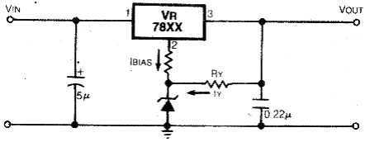
Schematic for constant high-voltage power supplies

It should be noted here that the maximum input voltage allowed for 78XX regulators is 35V between pins 1 and 2. We see that the actual voltage betweens pin 1 and 2 of the regulator in this circuit is
V_{IN} - V_{Z} - IBIAS R_{X}
It is therefore necessary that VIN be so chosen that voltage between pins 1 and 2 of the IC does not exceed the maximum rating. Also, a high input-output differential voltage V_{IN}-V_{OUT} means more power dissipation in the series-pass element, the regulator. Thus, with proper selection of the input transformer voltage and capacitor, this should be minimized.

For example, if 7805 is used, V_{R} equals + 5_{V} and V_{Z} is 40V, so V_{OUT}=45 volts. For 7805, the maximum input voltage is 35 V and the minimum 7V.
Therefore,
V_{IN} _{MAX} = 45 + 35 - 5 = 75 VOLTS
V_{IN MIN} = 45 + 7 - 5 = 47 VOLTS

Thus, from no-load to full-load condition, the unregulated input voltage-including peak ripple-should be within these limits. This gives a margin of 75-47, i.e. 28 volt. Hence, the designer can work out the maximum transformer voltage from the no-load input voltage chosen on the upper side.
The capacitor's value can be determined from the full load unregulated voltage chosen. Roughly, per 100mA current, 100mf capacitor gives 1-volt peak-to-peak ripple. Hence, capacitor's value can be determined for the desired current.
This circuit will have an excellent load and line regulation. For shot-circuit protection, it is recommended to use a fast-blow fuse of suitable value. Although the regulator has inherent short-circuit protection, the maximum current differs from device to device. Adequate heat sink should be used with the regulator.

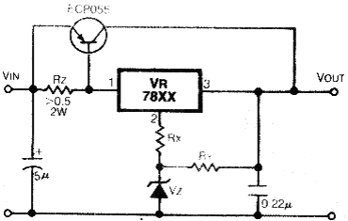
Schematic for constant high-voltage power supplies providing currents in excess of one ampere

Now if currents in excess of 1A are needed, the circuit shown in fig. is useful. This circuit is similar to that in Fig. except that a pass transistor ECP055 is added besides a 0.5-ohm or more resistor. This transistor bypasses the excessive current. By selecting proper R_{z} the ratio of two currents passing through the regulator and transistor can be altered.
This circuit will show load and live regulation within 1% and will function properly for V_{IN}-V_{OUT} as low as 4 volt. For short-circuit protection, a fast blow fuse is recommended as this circuit does not have inherent short-circuit protection. Adequate heat sink is to be used for the pass transistors. For negative voltages, use 79XX series regulators and ECN055 as the pass transistor. Some advantages of the circuits described above are: the lowest cost among comparable performance circuits, ability to work at low input-output differential, and flexibility in design for various applications.
So audio enthusiasts, if you are troubled by hum emanating from your power amplifier, try this inexpensive alternative for power supply.

DRIVING LCD

INTRODUCTION:
The LCD is a dot matrix liquid crystal display that displays alphanumeric, Kana (Japanese) character and symbols. The built - in controller & driver LSIs provide convenient connectively between a dot matrix LCD and most 4 or 8 bit microprocessors or microcontrollers. All the functions required for dot matrix liquid crystal display drive are internally provided. Internal refresh is provided by the LCD. The CMOS technology makes the device ideal for application in hand held, portable and other battery powered instruments with low power consumption.

FEATURES:
- Easy interface with a 4-bit or 8-bit MPU.
- Built-in dot matrix LCD controller with font 5 X 7 or 5 X 10 dots.
- Display data RAM for 80 characters (80 X 8bits).
- Character generator ROM, which provides 160 characters with font
5 X 7 dots and 32 characters with font 5 X 10 dots.
- Both display data and character generator RAMs can be read from the
MPU.
- Internal automatic reset circuit at power ON.
- Built-in oscillator circuit (No extra clock required).
- Wide range of instruction functions: Clear display, cursor home,
Display ON/OFF, Cursor Shift, Display Shift.

OPERATIONAL OVERVIEW:
1. BUSY FLAG (BF):
When the busy flag is HIGH level, it indicates that the controller is in the internal operation mode and the next instruction will not be accepted. When R/W is ‘1’ and Rs is ‘0’, the busy flag is output from DB_{7.} The next instruction must be written after the busy flag goes low.

2. ADDRESS COUNTER (AC):
The address counter (AC) generates the address for the DD RAM, the CG RAM and for the cursor display. When an instruction code for DD or CG RAM address is written to the controller, after deciding whether it is DD RAM or CG RAM, the address information is transferred to AC. After writing into DD or CG RAM display data, AC is automatically incremented (or decremented). The data of AC is output DB₀~DB₀ when RS is’0’ and R/W is’1’.

3. CHARACTER GENERATOR ROM (CG ROM):
The character generator ROM generates 5 X 7 dot or 5 X10 dot character pattern from 8-bit character codes. It can generate 160 types of 5 X7 dot character pattern and 32 types of 5 X 10 dot character patterns. When the 8-bit character code of a CG ROM is written to the DD RAM, the character pattern of the CG ROM corresponding to the code is displayed on the LCD display position corresponding to the DD RAM.

4. CHARACTER GENERATOR RAM (CG RAM):
The character generator RAM (CG RAM) is the RAM with which the user can generate character patterns by program. The CG RAM has the capacity to store 8 kinds of 5 X 7 dots or 4 kinds of 5 X 10 dots. Programming of this character patterns is explained in CG RAM programming.

5. DISPLAY DATA RAM (DD RAM):
The display data RAM (DD RAM) stores display data represented in 8-bit (hexadecimal) character codes. Its capacity is 80 X 8 bits, or 80 characters. The display data RAM (DD RAM) that is not used for display can be used as general data RAM. Depending on the 8-bit character code that is written into the DD RAM. LCD will select the character pattern either from Character Generator RAM (CG RAM) or from Character Generator ROM (CG ROM).
1-line Display (N=O)

1 2 3 4 5 78 79 80 Display position
00 01 02 03 04 -- -- -- 4D 4E 4F

Line-1 DD RAM address
When the display characters are less than 80, the display begins at the home position. For example, 8 characters X 1 line will be like:
1 2 3 4 5 6 7 8 Display position
00 01 02 03 04 05 06 07
DD RAM address

When the display shift operation is performed, the DD RAM address moves as:

(Left shift display)
00 01 02 03 04 05 06 07
(Right shift display)
00 01 02 03 04 05 06 07

2-line Display (N=1)
1 2 3 4 5 6 -- -- 39 40 Display position
00 01 02 03 04 05 -- -- 26 27
Line-1
DD RAM address
40 41 42 43 44 45 -- -- 66 67

Note that the first line end address and the second line start address are not consecutive. When the capacity is less than 40 X 2, the 2 lines are displayed from the home position.

For example 16 characters X 2 lines will be like:
1 2 3 4 5 6 7 8 9 10 11 12 13 14 15 16 Display
Line-1
00 01 02 03 04 05 06 07 08 09 0A 0B 0C 0D 0E 0F
DDRAM
40 41 42 43 44 45 46 47 48 49 4A 4B 4C 4D 4E 4F
Line-2 address

When display shift is performed, the DD RAM address move as:
01 02 03 04 05 06 07 08 09 0A 0B 0C 0D 0E 0F 10

Left shift
41 42 43 44 45 46 47 48 49 4A 4B 4C 4D 4E 4F 50

27 00 01 02 03 04 05 06 07 08 09 0A 0B 0C 0D 0E

Right shift
67 40 41 42 43 44 45 46 47 48 49 4A 4B 4C 4D 4E
display

INSTRUCTION CODE:
The instruction code is a command set through which the LCD is controlled by the MPU. Prior to internal execution of the instruction code, control information is temporally stored in the internal resisters of the LCD, to allow interface from LCD’s internal operation to various types of MPUs, which operate at different speeds or allow to interface to peripheral control ICs. The LCD begins operation upon receipt of the instruction code input from the MPU. There are four types of instruction, those that:
- Designate LCD functions such as display format, data length, etc.
- Define internal RAM address.
- Perform data transfer with internal RAM.
- Others.

Normally the, 3rd category of instruction are used frequently, Automatic incrementing (or decrementing) of LCD internal RAM address after each data write lessens the MPU program load. The display shift is performed concurrently with display data write, enabling the user to develop system in minimum time with maximum programming efficiency. When an instruction is executing during internal operation, no instruction other than busy flag/address read instruction will be executed.
The busy flag is set to’1’ while the LCD is internally processing an instruction. LCD signals that it is ready to accept the instruction by resetting the Busy flag. It is therefore to be ensured that the instructions are written to the LCD only while the busy flag is ‘0’. There are two ways of doing this:
- Read the Busy flag and ensure it is ‘0’ before writing any instruction to the LCD.
- Provide a sufficiently large delay between instructions to the LCD.

INSTRUCTION TABLE:

Instru-ction | Code | Description | Execute time (max)
Instru-ction | RS R/W DB7 DB6 DB5 DB4 DB3 DB2 DB1 DB0 | Description | Execute time (max)
Clear display | 0 0 0 0 0 0 0 0 0 1 | Clears all display and returns cursor to home position (address 0). | 1.64mS
Cursor at home | 0 0 0 0 0 0 0 0 1 * | Returns the cursor to the home position (address 0). Also returns the display being shifted to original position. DDRAM contents remain unchanged. | 1.64mS
Entry mode set | 0 0 0 0 0 0 0 1 I/D S | Sets the cursors move direction and specifies shift of display. These operations are performed during data write and read. | 40μS
Display ON/OFF control | 0 0 0 0 0 0 1 D C B | Sets ON/OFF of all display (D) cursor ON/OFF (C), and blink of cursor position character (B). | 40μS
Cursor/display shift | 0 0 0 0 0 1 S/C R/L * * | Moves the cursor and shifts the display without changing DDRAM contents. | 40μS
Function set | 0 0 0 0 1 DL N F * * | Sets interface data length (DL) number of display lines (L) and character font (F). | 40μS
CGRAM address set | 0 0 0 1 ACG | Sets the CGRAM address. CGRAM data is sent and received after this setting. | 40μS
DDRAM address set | 0 0 1 ADD | Sets the DDRAM address. DDRAM data is sent and received after this setting. | 40μS
Busy flag/add-ress read | 0 1 BF AC | Reads busy flag (BF) indicating internal operations are being performed and reads address counter contents. | 40μS
CGRAM/DDRAM write | 1 0 Write data | Writes data into DDRAM or CGRAM. | 40μS
CGRAM/DDRAM read | 1 1 Read data | Reads data from DDRAM or CGRAM. | 40μS

DESCRIPTION OF INSTRUCTION CODE:
1. CLEAR DISPLAY:
RS R/W DB7 DB6 DB5 DB4 DB3 DB2 DB1 DB0
0 0 0 0 0 0 0 0 0 1

When this instruction is executed, the LCD display cleared and returned to its original status if it is shifted. The cursor goes to left edge of the display (the left end of the first line if 2-line mode). Space code ‘20’ (hexadecimal) (character pattern for character code ‘20’ is blank pattern) is written into all DD RAM addresses. Sets DD RAM address 0 in address counter (AC). Sets I/D = ‘1’ (Increment Mode) of Entry Mode. S of Entry Mode Doesn’t change.

2. RETURN HOME:
RS R/W DB7 DB6 DB5 DB4 DB3 DB2 DB1 DB0
0 0 0 0 0 0 0 0 0 *
Code
Higher order bits Lower order bits
* NO effect
The cursor or blink goes to the left edge of the display (to the left end of the first line in the 2 line display mode). The display returns to its original status if it was shifted. DD RAM contents do not change. Sets the DD RAM address 0 in address counter.

3. ENTRY MODE SET:

RS R/W DB7 DB6 DB5 DB4 DB3 DB2 DB1 DB0
0 0 0 0 0 0 0 1 I/D S
Code
Higher order bits Lower order bits

I/D: when the I/D is set, the 8-bit character code is written or read to and from the DD RAM, the cursor shifts to the right by 1 character position (I/D = ‘1’; increment) or to the left by 1 character position (I/D =’0’; decrement). The address is incremented (I/D = ‘1’) or decremented (I/D =’0’) by 1 at this time. Even after the character pattern code is written or read to end from the CG RAM, the address counter (A/C) is incremented (I/D = ‘1’) or decremented (I/D = ‘0’) by 1.

S: Shift the entire to the right or to the left when s is 1; to the left when I/D =1 and to the right when I/D = 0. Thus it looks as if the cursor stands still the display moves. The display does not shift when reading from the DD RAM when or when writing in to or reading out from the CG RAM when S=0.

4. DISPLAY ON/OFF CONTROL:
RS R/W DB7 DB6 DB5 DB4 DB3 DB2 DB1 DB0
0 0 0 0 0 0 1 D C B
Code
Higher order bits Lower order bits

D: The display is ON when D = ‘1’ and OFF when D = ‘0’. When off due to D = ‘0’, display data remains in the DD RAM. It can be displayed immediately by setting d = ‘1’.

C: The cursor is displayed when C = ‘1’ and goes off when C = ‘0’. Even if the cursor disappears, the function of I/D, etc. does not change during display data write. The cursor is displayed using 5 dots in the 8th line when the 5x7 dot character font is selected and 5 dots in the 11th line when the 5x10 dot character font is selected.

B: The character indicated by the cursor blinks when B = ‘1’. The blink is displayed by switching all black dots and display characters at 409.6 ms interval when f_{CP} or f_{OSC} = 250 kHz. The cursor and the blink can be set to display simultaneously. (The blink interval changes according to the reciprocal of f_{CP} or f_{OSC}. 409.6 X 250/270 = 379.2 ms when f_{CP} + 270kHz).

5. CURSOR OR DISPLAY SHIFT:

RS R/W DB7 DB6 DB5 DB4 DB3 DB2 DB1 DB0
0 0 0 0 0 1 S/C R/L * *
Code

Higher order bits Lower order bits
* No effect
Shifts cursor position or display to the right or left without writing or reading display data. This function is used to correct or search for the display. In a 2-line display, the cursor moves to the second line when it is passes the 40th digit of the 1st list. Notice that the 1st and 2nd line displays will shift at the same time. When the displayed data is shifted repeatedly each line only moves horizontally. The 2nd line display does not shift into the 1st line position.

S/C R/L
0 0 Shifts the cursor position to the left.
(AC is decremented by one).
0 1 Shifts the cursor position to the right
(AC is incremented by one).
1 0 Shifts the entire display to the left.
The cursor follows the display shift.
1 1 Shifts the entire display to the right.
The cursor follows the display shift.

Address counter (AC) contents do not change if the only action performed is shift display.

6. FUNCTION SET:

RS R/W DB7 DB6 DB5 DB4 DB3 DB2 DB1 DB0
0 0 0 0 1 DL N F * *
Code
Higher order bits Lower order bits
* No effect
DL: Sets interface data length
When DL =’1’, the data input/output to and from the MPU is carried out by means of 8 bits DB₇ to DB₀. When DL =`0’, the data input/output to and from the MPU is carried out in two steps through the 4 bits DB₇ to DB₄.

N: Sets number of display lines
The 2-line display mode of the LCD is selected when N =’1’, while the 1-Line display mode is selected when N = ‘0’

F: Sets character font
The 5x7 dots character font is selected when F =’0’, while the 5x10 dots character font is selected when F = ‘1’1 and N =’0’.

7. SET CG RAM ADDRESS:

RS R/W DB7 DB6 DB5 DB4 DB3 DB2 DB1 DB0
0 0 0 1 A5 A4 A3 A2 A1 A0
Code

Higher order bits Lower order bits
Sets CG RAM address in to the Address Counter in binary A5 to A0. In the 5 X 10 font mode A5 & A4 define the CG RAM block number while A3-Ao define the row with in the block. In the 5 X 7 font mode the CG RAM block is defined by A5-A3 while A2- A0 define the row.

8. SET DD RAM ADDRESS:
RS R/W DB7 DB6 DB5 DB4 DB3 DB2 DB1 DB0
0 0 1 B6 B5 B4 B3 B2 B1 B0
Code

Higher order bits Lower order bits
Sets the DD RAM address into the address counter in binary B6 to B0. Data then written or read from the LCD pertains to the DD RAM. However, when N= ‘0’ (1-line display), B6 to B0 is ‘00’~ ‘4F’ (hexa). When N = ‘1’ (2-line display), B6 to B0 is ‘00’ ~ ‘27’ (hexa) for the first line, and ‘40’~’67’ (hexa) for the second line.

9. READ BUSY FLAG AND ADDRESS:

RS R/W DB7 DB6 DB5 DB4 DB3 DB2 DB1 DB0
0 1 BF C6 C5 C4 C3 C2 C1 C0
Code
Higher order bits Lower order bits

Reads the busy flag (BF) that indicates the system is now internally executing a previously received instruction. BF = ‘1’ indicates that internal operation is in progress. The next instruction will not be accepted until BF goes ‘0’. Check the BF status before the next write operation.

At the same time, the value of the address counter expressed in binary C6 toC0 is read. The address counter is used by both CG and DD RAM addresses, and its value is determined by the previous instruction.

10. WRITE DATA TO CG TO DD RAM:
RS R/W DB7 DB6 DB5 DB4 DB3 DB2 DB1 DB0
1 0 D D D D D D D D
Code
Higher order bits Lower order bits

Writes binary 8 data DDDDDDDD to the CG or the DD RAM. Whether the CG or DD RAM is to be written in to is determined by previous specification of CG RAM or DD RAM address setting. After write, the address is automatically incremented or decremented by 1 according to entry mode. The entry mode also determines display shift.

11. READ DATA FROM CG OR DD RAM:

RS R/W DB7 DB6 DB5 DB4 DB3 DB2 DB1 DB0
1 1 D D D D D D D D
Code
Higher order bits Lower order bits

Reads binary 8 bit data DDDDDDDD from the CG or DD RAM. The previous designation determines whether the CG or DD RAM is to be read. Before entering the read instruction, you must execute either the CG RAM or DD RAM address set instruction. If you do not, the first read data would be invalid.

SOFTWARE:
1. Appendix 1:
How to compile the demo program?

- Start the software Keil uVision4.
- In the menu, select Project -> New Project.
- Select Device for Target. Click Philips -> P89V51RD2, click OK.
- Project -> Options for Target. Select tab “Output”. Click check box
“Create HEX File”. Click OK.
- You can press F7 or select Project -> Build Target to compile the C
program and link the object file to HEX file.
- If everything is OK, a Hex file should be created and a message
creating new file from “main” will prompt out.

TEMPERATURE SENSOR:
Here we use LM 335 as a temperature sensor. Output of the temperature sensor is further connected to the op-amp circuit. Op-amp circuit amplify the signal from the temperature sensor and then this signal is further connected to the ADC 0809. Output of the ADC is connected to the micrcocontroller circuit. Microcontroller process the logic and then this logic is connected to the lcd driver circuit. LCD display the current temperature and set temperature at a time. Set temperature is set by the outside switches. With the help of these switches we set the temperature and . Current temperature that display on the lcd is display and compare with the set value of the controller. When current value is above from the set value then output load or heater is off. As the temperature is down from the set value then output load is again on. Once we set the value then temperature is to be maintain between these two value and stay here between the set point and current point.
Out project is to be dived in two many parts.
Sense the temperature by the temperature sensor.

AMPLIFY THE TEMPERATURE SIGNAL BY THE OP-AMP CIRCUIT.
Convert analogue signal into digital signal.
Digital signal is processed by the microcontroller and then convert it into ASCII code.
ASCII code is to be display on the lcd by set value and current value
Set the temperature from the outside.
Switch on the load circuit with microcontroller.
NEXT IMPORTANT PART OF THIS PROJECT IS LM 35 TEMPERATURE SENSOR. BY USING THIS SENSOR WE GIVE A INPUT TO THE ADC AND THEN USE THE ADC INTO MICROCONTROLLER CIRCUIT
Temperature Sensor - The LM35
The LM35 is an integrated circuit sensor that can be used to measure temperature with an electrical output proportional to the temperature (in ºC)
The LM35 - An Integrated Circuit Temperature Sensor
- Why Use LM35s To Measure Temperature?
  - You can measure temperature more accurately than a using a thermistor.
  - The sensor circuitry is sealed and not subject to oxidation, etc.
  - The LM35 generates a higher output voltage than thermocouples and may not require that the output voltage be amplified.
- What Does An LM35 Look Like?
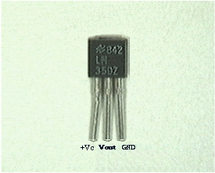
- What Does an LM35 Do? How does it work?
  - It has an output voltage that is proportional to the Celsius temperature.
  - The scale factor is .01V/ºC
  - The LM35 does not require any external calibration or trimming and maintains an accuracy of +/-0.4 ºC at room temperature and +/- 0.8 ºC over a range of 0 ºC to +100 ºC.
  - Another important characteristic of the LM35DZ is that it draws only 60 micro amps from its supply and possesses a low self-heating capability. The sensor self-heating causes less than 0.1 ºC temperature rise in still air.
The LM35 comes in many different packages, including the following.
- TO-92 plastic transistor-like package,
- T0-46 metal can transistor-like package
- 8-lead surface mount SO-8 small outline package
- TO-202 package. (Shown in the picture above)
- How Do You Use An LM35? (Electrical Connections)
  - Here is a commonly used circuit. For connections refer to the picture above.
  - In this circuit, parameter values commonly used are:
    - V_{c} = 4 to 30v
    - 5v or 12 v are typical values used.
    - R_{a} = V_{c} /10⁻⁶
    - Actually, it can range from 80 KW to 600 KW , but most just use 80 KW.
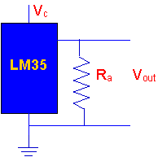
  - Here is a photo of the LM 35 wired on a circuit board.
    - The white wire in the photo goes to the power supply.
    - Both the resistor and the black wire go to ground.
    - The output voltage is measured from the middle pin to ground.l

